BACKGROUND VERIFICATION FORM – Zediant Technologies
Please provide complete and correct information with utmost attention; all this shall be verified by authorized representatives.
Personal Information
Name | Samiran Roy Bhowmik | Employee Code | ZT00030
Gender | Male | DOB | 14.02.2002
Designation | Java Intern Backend | Joining Date | 5th August 2025
Email | sroy21191@gmail.com | Mobile | 8101387643
Father’s Name | SatyaBrata Roy Bhowmik | Nationality | Indian

Residential Address
Current Address
Tarulia 1st Lane CityBidhannagarCountryIndia

City | Kolkata | State | West Bengal
Pincode | 700156 | Staying From
Permanent Address
Asansol,South Ranitala -713343,kulti

City | Asansol | State | West bengal
Pincode | 713343 | Staying From

Educational Information (Highest Certification)
College | MAULANA ABUL KALAM AZAD UNIVERSITY OF TECHNOLOGY, WEST  BENGAL | Group | West Bengal University of Technology)
Major Subject | Computer Science and Engineering | Location | Asansol, West Bengal
From Date | 02.08.2023 | To Date | 20.08.2024
Course Type | Regular
Certificate Submitted | CGPA(Cumulative Grade Point Average): 8.63

Employment History
Current Employer
Company Name | Zediant Technologies | Location | Ergo Tower, Floor - 13th, Unit - 1302  Block EP & GP, Street - 23, Salt Lake City, Sector-V, Kolkata-700091, W.B, India.
Employee ID | ZT | Designation | Backend Java Intern
From Date | 5th August 2025 | To Date | Till date
Work Type | Intern | Department | Java
Reporting Manager | Benay Debnath | Designation
Mobile |  | Email
Employment Proof Document | - Experience Certificate  - Relieving Letter  - Payslips  - Any Other
Previous Employer (1)
Company Name |  | Location
Employee ID |  | Designation
From Date |  | To Date
Work Type | Regular | Part Time | Contract | Department
Reporting Manager |  | Designation
Mobile |  | Email
Employment Proof Document | - Experience Certificate  - Relieving Letter  - Payslips  - Any Other
Previous Employer (2)
Company Name |  | Location
Employee ID |  | Designation
From Date |  | To Date
Work Type | Regular | Part Time | Contract | Department
Reporting Manager |  | Designation
Mobile |  | Email
Employment Proof Document | - Experience Certificate  - Relieving Letter  - Payslips  - Any Other
Previous Employer (3)
Company Name |  | Location
Employee ID |  | Designation
From Date |  | To Date
Work Type | Regular | Part Time | Contract | Department
Reporting Manager |  | Designation
Mobile |  | Email
Employment Proof Document | - Experience Certificate  - Relieving Letter  - Payslips  - Any Other

DECLARATION

I hereby declare that all the information provided here is true and complete to the best of my knowledge and belief. I promise to extend total cooperation and provide relevant documents if required.

Place: Kolkata 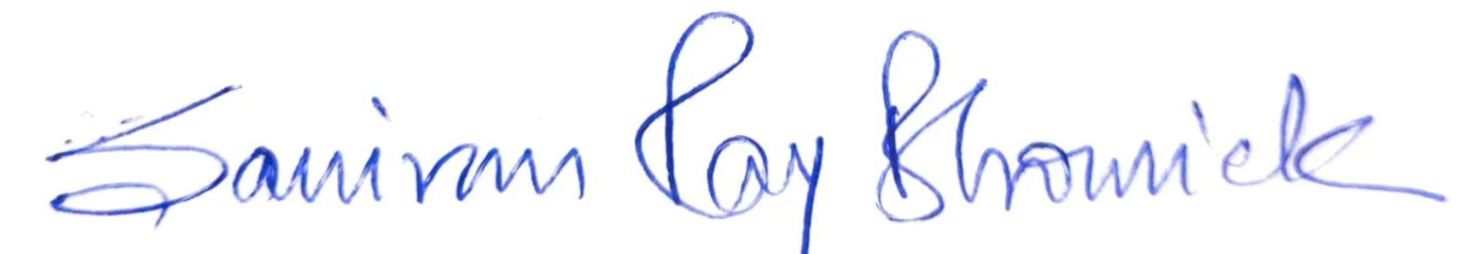
Date: 16.08.2025 Applicant’s Signature

